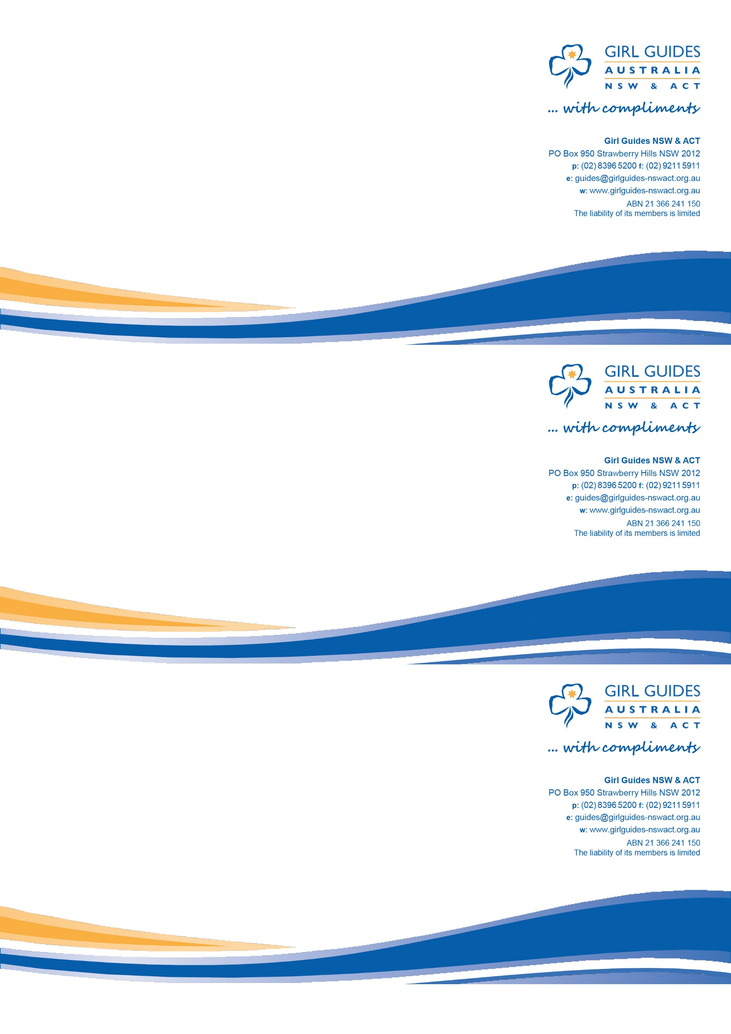

A Unit to visit

## Unit:

## Address:

## Day:

## Time:

## Contact:

A Unit to visit

## Unit:

## Address:

## Day:

## Time:

## Contact:

A Unit to visit

## Unit:

## Address:

## Day:

## Time:

## Contact:

dicant similique, sed at salutatus scribentur. Vel unum vidisse oblique ut. In tation omnium omittam qui, ius ex postea accusam delectus.